**Getting Started with CloudPC for Statistical Software Use at UMass Boston**

1. **Navigate to the CloudPC Website**

Open your web browser and to:

<https://www.umb.edu/it/software-systems/cloudpc/>

1. **Start Cloud PC**
   * 1. Click on Start CloudPC

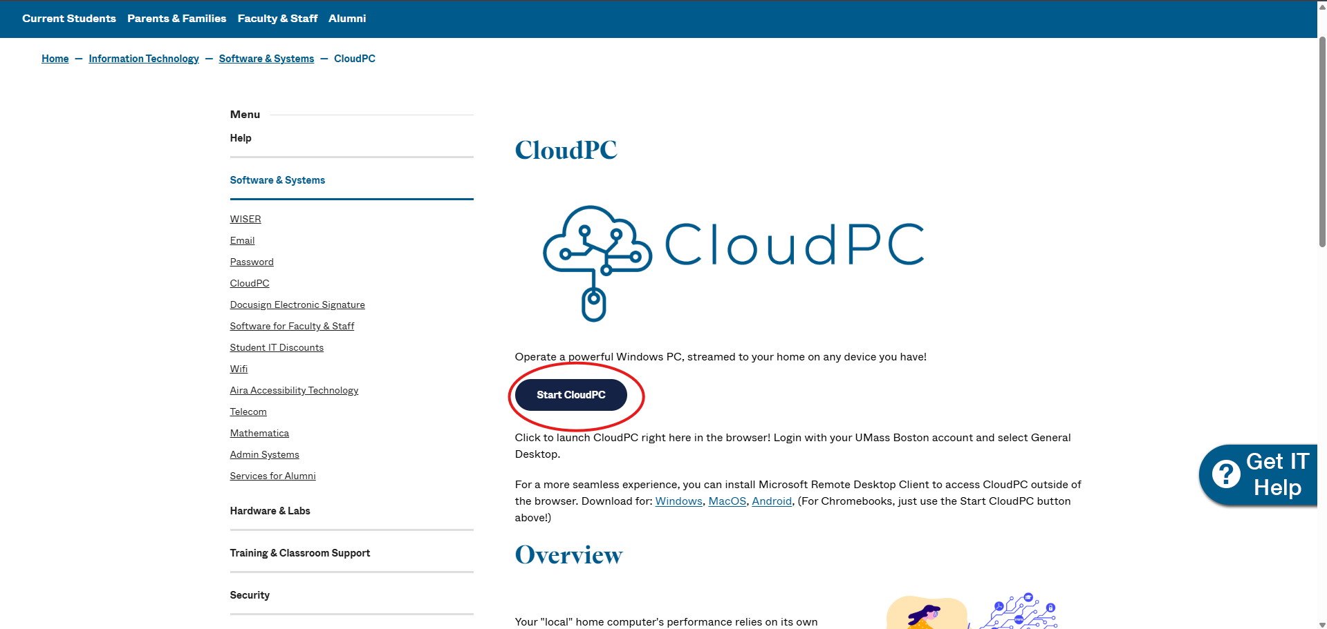

* + 1. Select CloudPC V2 – Windows 10, as it is highlighted below:

1. **Allow Access Local resources**

1. **Log in with your UMass Boston Account**

You will be prompted to log in using your firstname.lastname@[umb.edu](http://umb.edu) email address. Enter your credentials and click on Submit.

1. **Wait for the system to load**.

After logging in, wait for the remote desktop environment to load. You should see a screen like your usual Windows desktop:

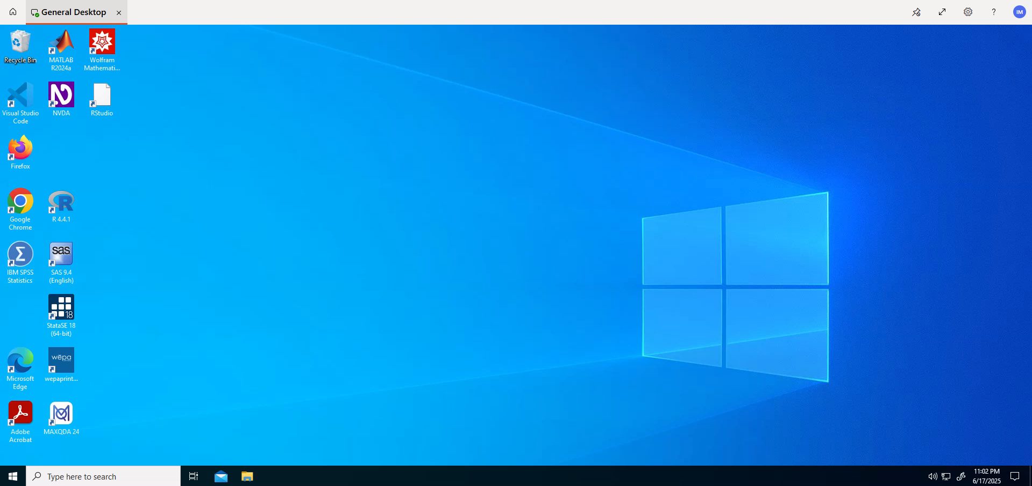

1. **Access Statistical Software**

You can now open statistical software available on Cloud PC, such as SPSS, Stata, and R.

To open an application:

* click on a shortcut icon on the desktop, or
* Use the Windows search bar.

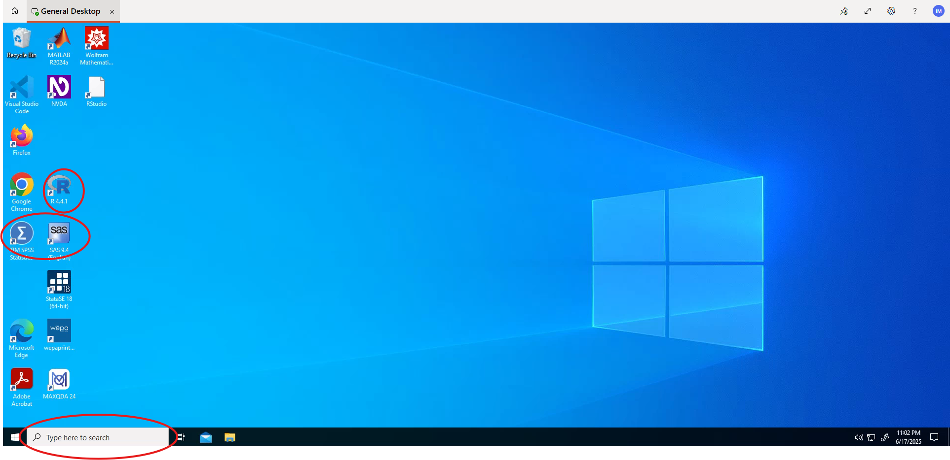

**Note on File Access**

Cloud PC is a remote computer, so it cannot directly access the files stored on your device.

To use your own data files:

* Upload them to OneDrive or
* Email them to yourself and download from your email on the CloudPC, like here:

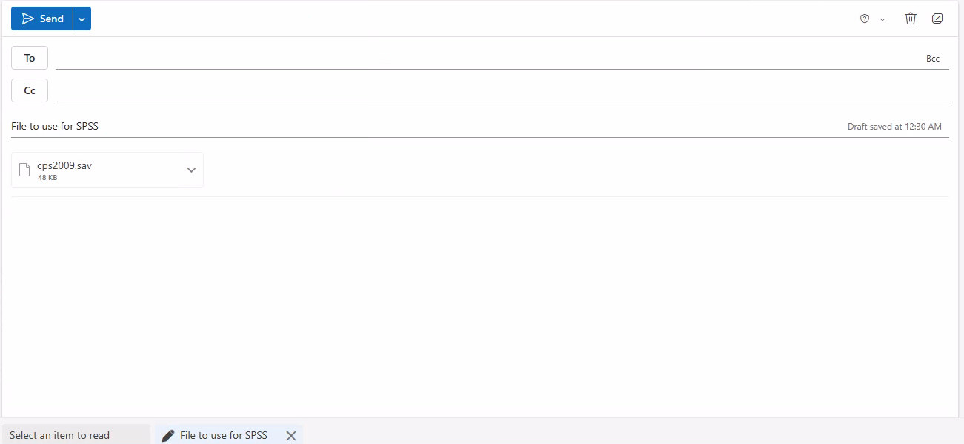

**Using SPSS on CloudPC**

1. To open SPSS, click on the SPSS shortcut or search for it in the Windows search bar.
2. If prompted to activate a license, choose the pre-licensed option (highlighted) and click the appropriate button
3. You will then see the SPSS starting screen.

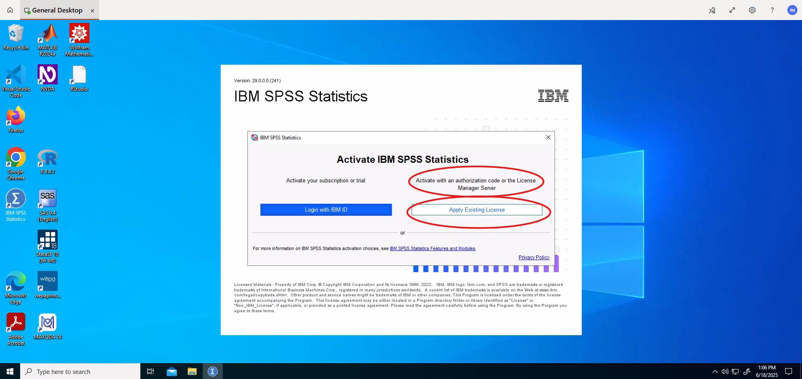

Suppose you have uploaded a file to a cloud drive that you wish to access through the remote PC, as in here:

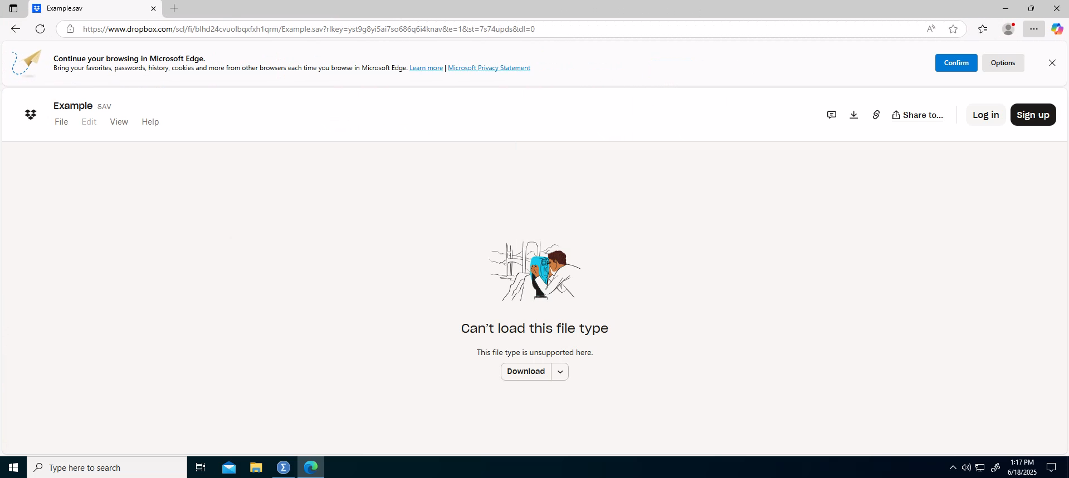  
This file is stored in Dropbox, a cloud storage service that allows users to upload their files and access them from anywhere.

This way, you can download files from your home computer to the remote PC.

Download the file, locate it on your CloudPC system.

Then, in SPSS, go to File - Open - Data, and select your .sav file:

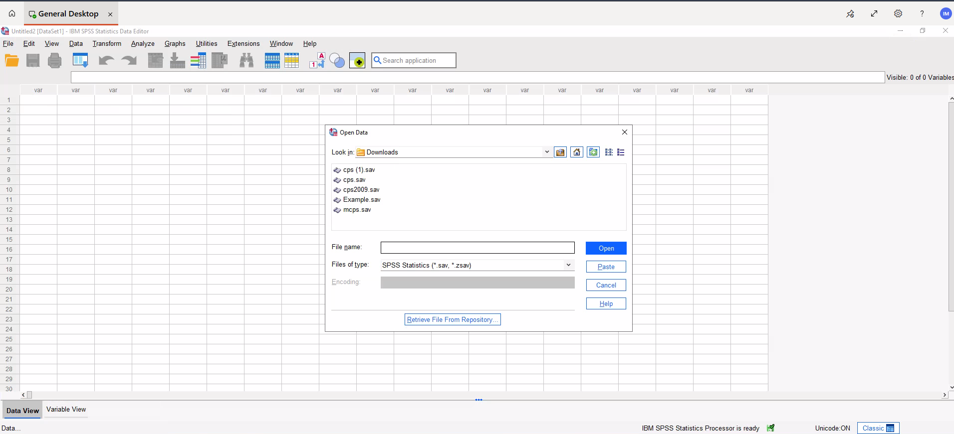

You are now ready to use SPSS in CloudPC.

Suppose we wish to perform a **t-test** comparing male and female groups from our sample dataset for a variable like personal total income.

**1. Open your .sav file:**

* Launch **SPSS**.
* Go to **File > Open > Data**.
* Select your .sav file.

**2. Check your variables:**

* Ensure the variable ptoinc is continuous (scale).
* Make sure the **gender variable** (used for grouping) clearly distinguishes **male** and **female** (e.g., coded as 1 = Male, 0 = Female, or labeled accordingly).

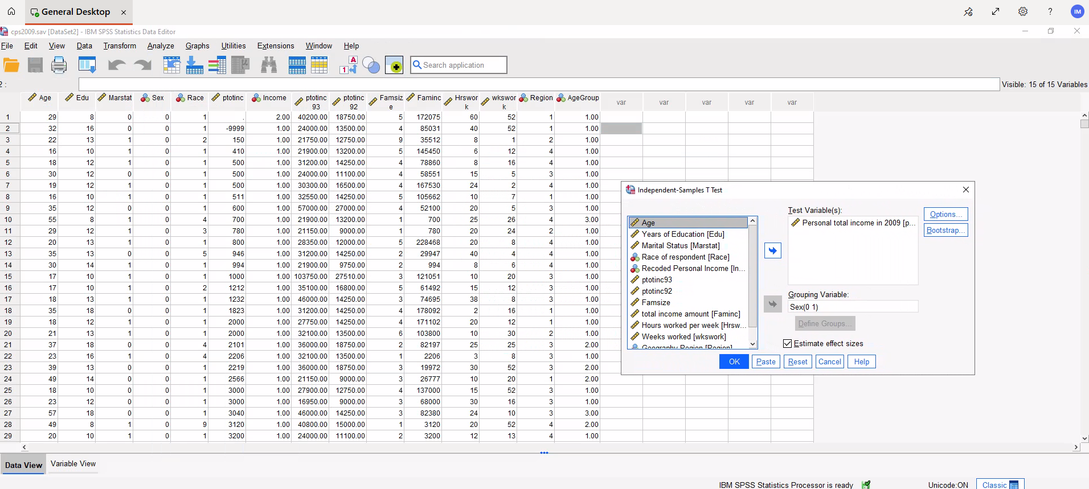

**3. Run the Independent Samples t-Test:**

1. Go to **Analyze > Compare Means > Independent-Samples T Test**.
2. In the dialog box:
   1. Move `ptoinc` into the **Test Variable(s)** box.
   2. Move your gender variable into the **Grouping Variable** box.
3. Click **Define Groups**:
   1. Enter the codes for **male** and **female** (e.g., 1 and 0) based on your dataset.
   2. Click **Continue**.
4. Click **OK** to run the test.

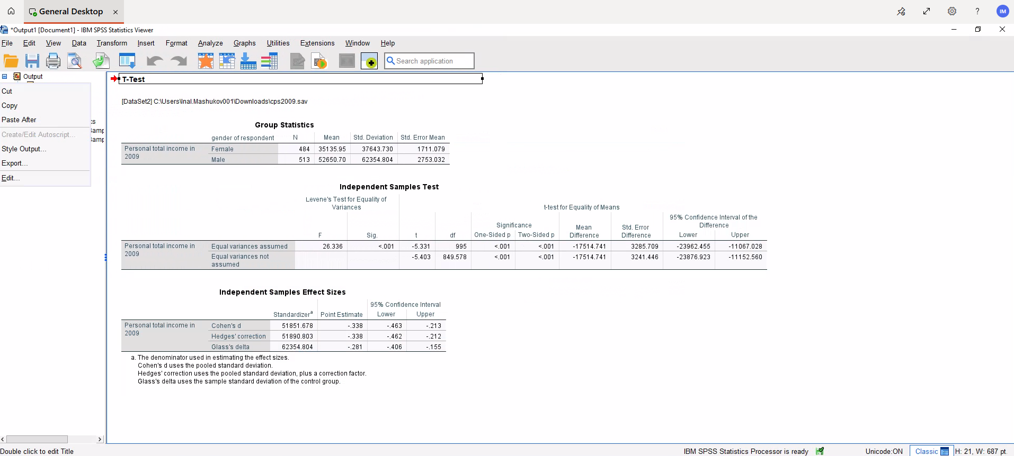

You are now ready to use CloudPC, along with the other statistical software such as Stata and SAS.

If you have any further questions, please contact:

[itservicedesk@umb.edu](mailto:itservicedesk@umb.edu)